Ant Colony Optimisation for Job Shop Scheduling
Sjoerd van der Zwaan, Carlos Marques
Instituto de Sistemas e Robótica, Instituto Superior Técnico (IST). Av. Rovisco Pais 1, 1096 Lisboa codex
Introduction
Ant System:
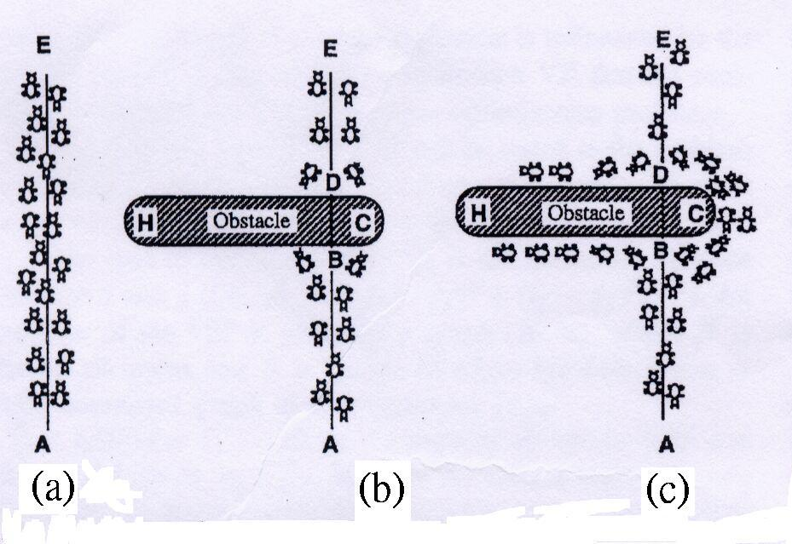
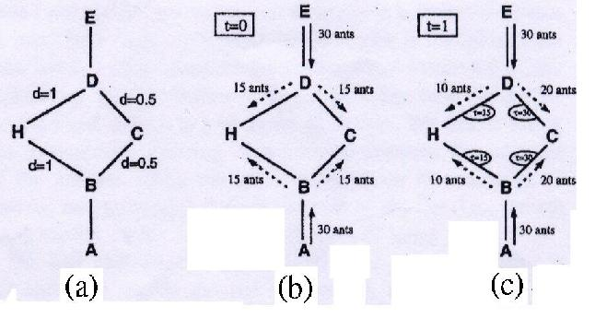

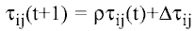 (1)

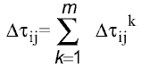 (2)

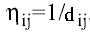 (3)

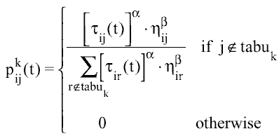 (4)

Job Shop Scheduling
A model of the n-job, m-machine job shop problem, denoted by:

n/m/G/C_{max}
The parameter G, indicates that jobs are connected with technological production rules describing their processing order of machines. This order is specified as the matrix T.
Ex:
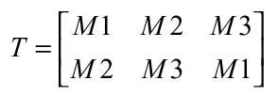
A row of the matrix represents a job, specifying the sequence of machines to be scheduled. Each element of the matrix T is referred to as an operation.

The processing time of each operation is specified by matrix P:

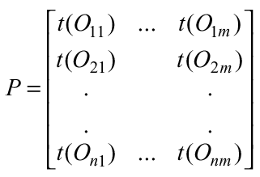

The matrices T and P define a job shop problem. The parameter C_{max} stands for the minimum make-span of the job-shop and indicates the performance measure used to minimize.
Implementation

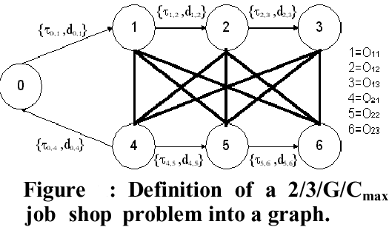

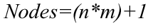

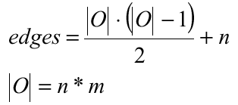
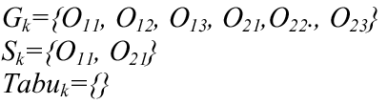

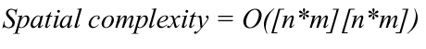

Where NC is the number of cycles, l represents the number of ants and [n*m] equals the number of operations defined by the job shop problem.

Created by : Chie-Yao hsu
Date : Aug. 15, 2002

